Laboratoriya ishi №6

Mavzu: Formani yaratish va elementlarini ishlatish (input, textarea, select)

Fan: Web ilovalar (HTML, CSS asoslari)

1. Ishdan maqsad
Veb-sahifada foydalanuvchi bilan o‘zaro aloqani ta’minlovchi forma yaratish, forma elementlarini (input, textarea, select) to‘g‘ri ishlatish va ularni CSS yordamida bezashni o‘rganish.

2. Nazariy ma’lumot
Formalar veb-sahifada foydalanuvchidan ma’lumot olish uchun ishlatiladi. HTMLda forma yaratish uchun <form> tegi ishlatiladi.

Asosiy teglar va atributlar
Teg / atribut | Tavsifi
<form> | Forma boshlanishi va tugashini bildiradi
action | Ma’lumot jo‘natiladigan manzil
method | Ma’lumot jo‘natish usuli (get, post)
<input> | Ma’lumot kiritish uchun turli elementlar
<textarea> | Ko‘p satrli matn kiritish maydoni
<select> va <option> | Tanlov menyusi
<button> | Tugma (forma yuborish yoki boshqa harakat)

<input> turlari
Type | Maqsadi
text | Matn kiritish
email | Elektron pochta manzili
password | Maxfiy parol kiritish
radio | Bir nechta variantdan bittasini tanlash
checkbox | Belgilash uchun katak
submit | Formani yuborish tugmasi
reset | Formani tozalash tugmasi

3. Amaliy qism (kod namunasi)

HTML fayl (index.html):
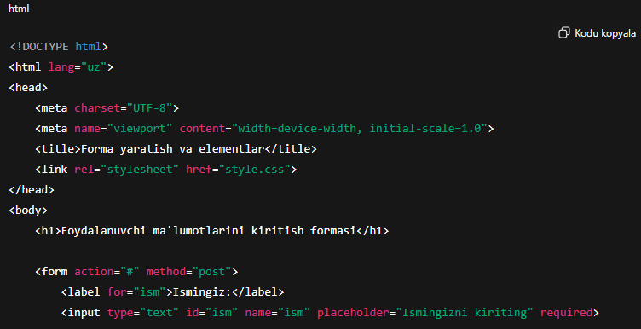
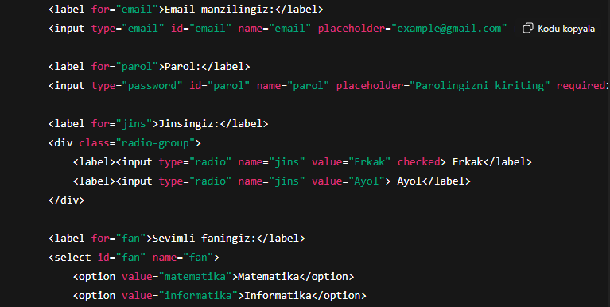
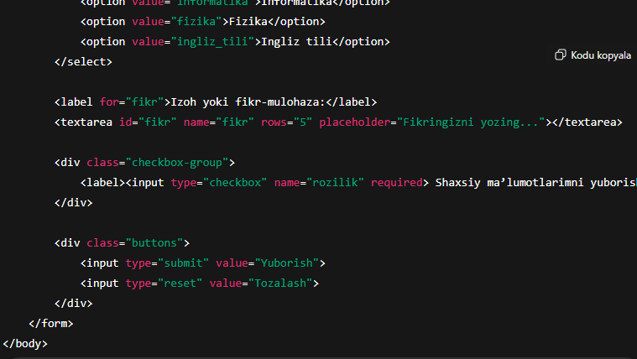

CSS fayl (style.css):

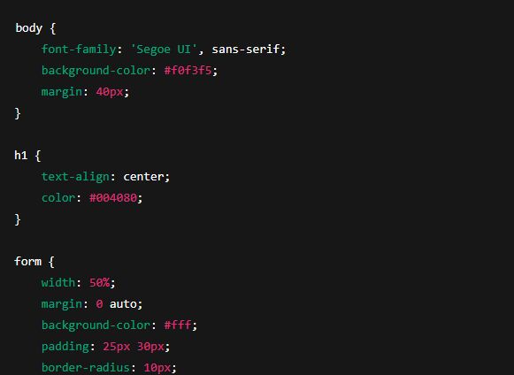
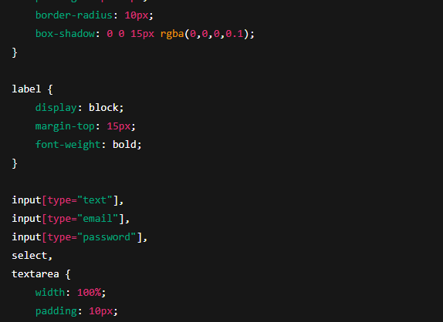
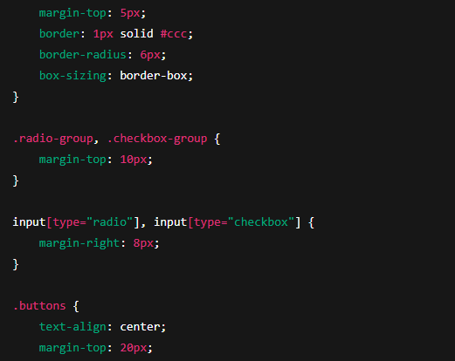
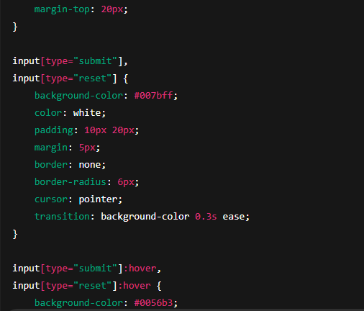

4. Natija
Yuqoridagi kodni ishga tushirganda quyidagi natija hosil bo‘ladi:
*Foydalanuvchi ismi, emaili, parolini kiritadi
*Radio tugmalar orqali jinsini tanlaydi
*select orqali sevimli fanini tanlaydi
*textarea orqali o‘z fikrini yozadi
*Checkbox orqali rozilik bildiradi
*“Yuborish” va “Tozalash” tugmalari ishlaydi
*Forma tartibli, chiroyli va zamonaviy dizaynda chiqadi
Topshiriq: Sumka do’konining sayti

<!DOCTYPE html>
<html lang="uz">
<head>
<meta charset="UTF-8">
<title>Brend Sumkalar Do'koni</title>
<style>
body {
font-family: Arial, sans-serif;
background-color: #ffc0cb; /* Pushti fon */
margin: 20px;
}
h1 {
text-align: center;
color: #fff;
text-shadow: 1px 1px 2px #000;
}
.container {
display: flex;
flex-wrap: wrap;
justify-content: center;
gap: 20px;
}
.product {
background-color: #fff;
border: 1px solid #ddd;
border-radius: 8px;
width: 250px;
padding: 10px;
box-shadow: 0 2px 5px rgba(0,0,0,0.1);
}
.product img {
width: 100%;
height: auto;
border-radius: 5px;
}
.product h2 {
font-size: 18px;
margin: 10px 0 5px;
text-align: center;
}
.product p {
font-size: 16px;
color: #555;
text-align: center;
}
</style>
</head>
<body>
<h1>Brend Sumkalar Do'koni</h1>
<div class="container">

<div class="product">
<img src="https://lombard-chasov.ru/images/products/WGhLHVZZblM0aJVNIeBFB6Wf2x3Ol0awkmsytSf4.jpg" alt="Chanel sumkasi">
<h2>Chanel</h2>
<p>Narxi: 250 000 so'm</p>
<p> Qizil, Oq, Qora ranglari bor</p>
</div>
<div class="product">
<img src="https://images.satu.kz/182561790_w640_h640_sumka-gucci-gg.jpg" alt="Gucci sumkasi">
<h2>Gucci</h2>
<p>Narxi: 300 000 so'm</p>
<p> To'q qizil, Oq, Qora ranglari bor</p>
</div>
<div class="product">
<img src="https://images.prom.ua/6582789822_w640_h640_sumka-louis-vuitton.jpg" alt="Louis Vuitton sumkasi">
<h2>Louis Vuitton</h2>
<p>Narxi: 200 000 so'm</p>
<p> Oq, Kulranglari bor</p>
</div>
<div class="product">
<img src="https://cdn1.ozone.ru/s3/multimedia-1-5/c600/7056374333.jpg" alt="Dior sumkasi">
<h2>Dior</h2>
<p>Narxi: 280 000 so'm</p>
<p> Oq va Pushti gulli ranglari bor</p>
</div>
<div class="product">
<img src="https://images.prom.ua/6522454428_w640_h640_zhenskaya-sumka-stil.jpg" alt="Zara sumkasi">
<h2>Zara</h2>
<p>Narxi: 450 000 so'm</p>
<p> Oq, Qora Kulranglari bor</p>
</div>
<div class="product">
<img src="https://images.uzum.uz/cmu93m125kub33f23do0/original.jpg" alt="Hermès sumkasi">
<h2>Hermès</h2>
<p>Narxi: 350 000 so'm</p>
<p> Har xil turdagi ranglari bor</p>
</div>
</div>
</body>
</html>

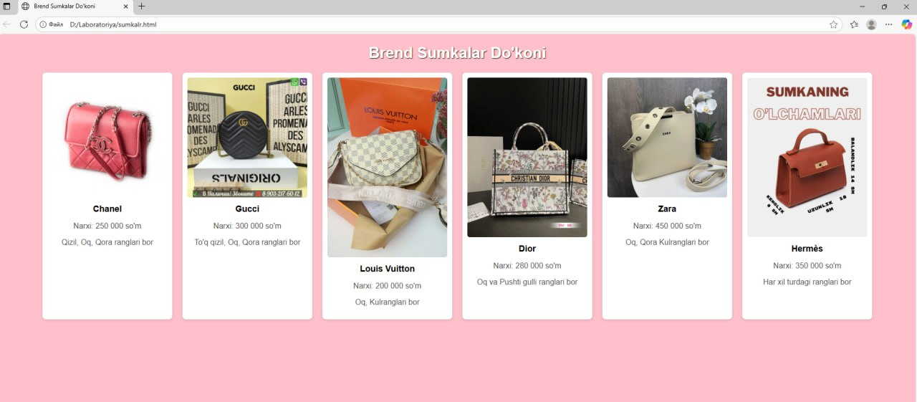

5. Xulosa
Ushbu laboratoriya ishida HTML forma tuzilmasi, asosiy elementlari (input, textarea, select) va ularning turlari o‘rganildi.
CSS yordamida forma elementlari bezatilib, foydalanuvchiga qulay interfeys yaratildi.
Bu mavzu foydalanuvchi ma’lumotlarini yig‘ish, ro‘yxatdan o‘tish, so‘rov yuborish kabi sahifalarni yaratishda juda muhim hisoblanadi.

